Electronic Voting System based on Asp.net

- Background/ Problem Statement

Voting is a method for a group of individuals to make a collective decision or voice their cumulative opinion to arrive at a consensus. The results of a vote can have far reaching consequences due to which it is imperative to maintain integrity by ensuring that there is no scope for fraud or cheating to occur while the votes are being cast. It is highly crucial that voting is carried out in a fair and just manner.
This Electronic Voting System has been developed to help eliminate any chance of tampering and improve the reliability and dependability of a voting system.
This system consists of two entities namely; The Admin and The Voter (The User).
Once the Voter has logged in to the system using their valid username and password, they can view the upcoming elections and the candidates contesting the election. Users can also view results once the elections have concluded. This system also shows user the elections that they have participated in so far.
On the other side of the application, the admin can view the list of candidates contesting, the list of voters, and the list of elections.
Since this system maintains the data using blockchain, it is highly dependable and can be easily scanned to check for signs of tampering and malpractice.

- Working of the Project

In this system, the admin is the sole authority to manage elections, candidates and voters. Admin can also view the votes. Admin can also check if any vote is tampered, thus checking and verifying the block.

Voter can view Elections and cast their vote, also can view the winner but cannot see the winning ratio or votes etc. The system uses Blockchain technology to create a block of every vote thus protecting its identity.

- Advantages
  - User cannot know any information about the vote
  - Votes cannot be tampered
  - Blockchain is used for votes

- System Description
The system comprises of 2 major modules with their sub-modules as follows:
Admin:
- Login:
  - Admin can login using id and password.
- Manage Elections:
  - Add/update/delete/view Elections.
- Manage Candidates:
  - Add/update/delete/view Candidates.
- Manage Voters:
  - Add/update/delete/view Voters.
- View Votes:
  - list of elections.
  - List of voters
  - Winner
  - Verify data with block created to know if its tampered
Voter:
- Login:
  - User can login in his personal account using id and password.
- Profile:
  - User can view and update his profile.

- Change Password:
  - can change the password within app

- Elections:
  - Pending / Participated
  - View elections
  - View Candidates
  - Cast Vote if not
  - Winner will be shown if election is complete

- Project Life Cycle

The waterfall model is a classical model used in system development life cycle to create a system with a linear and sequential approach. It is termed as waterfall because the model develops systematically from one phase to another in downward fashion. The waterfall approach does not define the process to go back to the previous phase to handle changes in requirement. The waterfall approach is the earliest approach that was used for software development

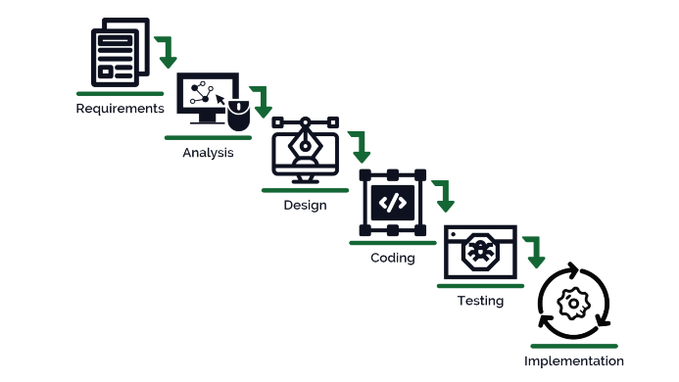

- System Requirement

- Hardware Requirement

- Laptop or PC
- Windows 7 or higher
- I3 processor system or higher
- 4 GB RAM or higher
- 100 GB ROM or higher

- Software Requirement

- Laptop or PC
- Visual Studio 2019
- SQL Server Management Studio latest

- Limitation/Disadvantages
- Wrong inputs will affect the project outputs.
- Internet Connection is mandatory
- The android mobile user will not be able to insert or view details if the server goes down. Thus, there is disadvantage of single point failure.
- Votes/Elections deleted cannot be restored
- Not using any government id
- Cannot register

- Application – This System can be used by any institution or body which wants to use a Voting system.

- Reference
- https://docs.microsoft.com/en-us/dotnet/
- https://stackoverflow.com/
- https://www.tutorialspoint.com/index.htm
- https://medium.com/

